SEQUENCE MODELS

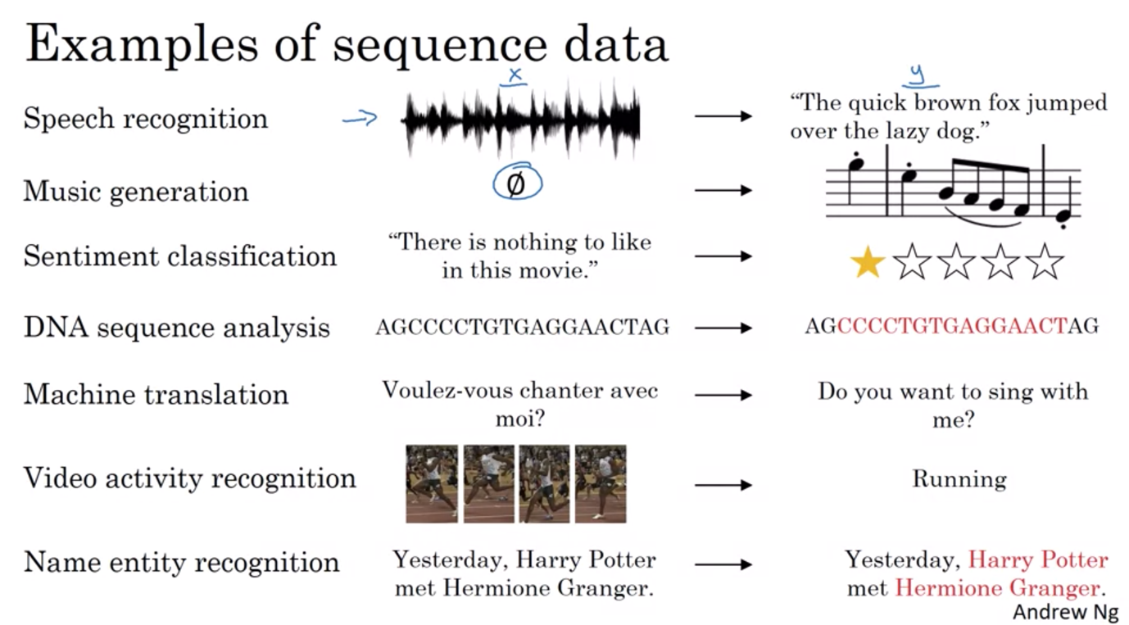

Week 1 – Recurrent Neural Network

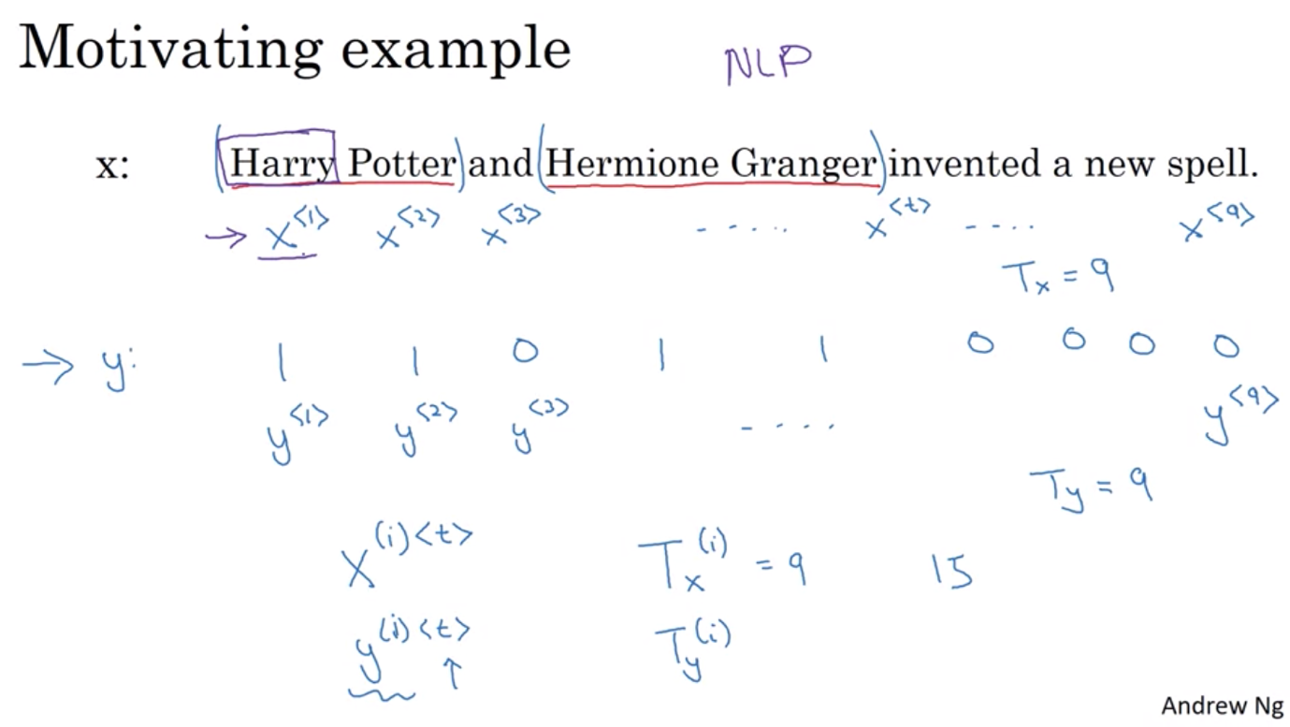

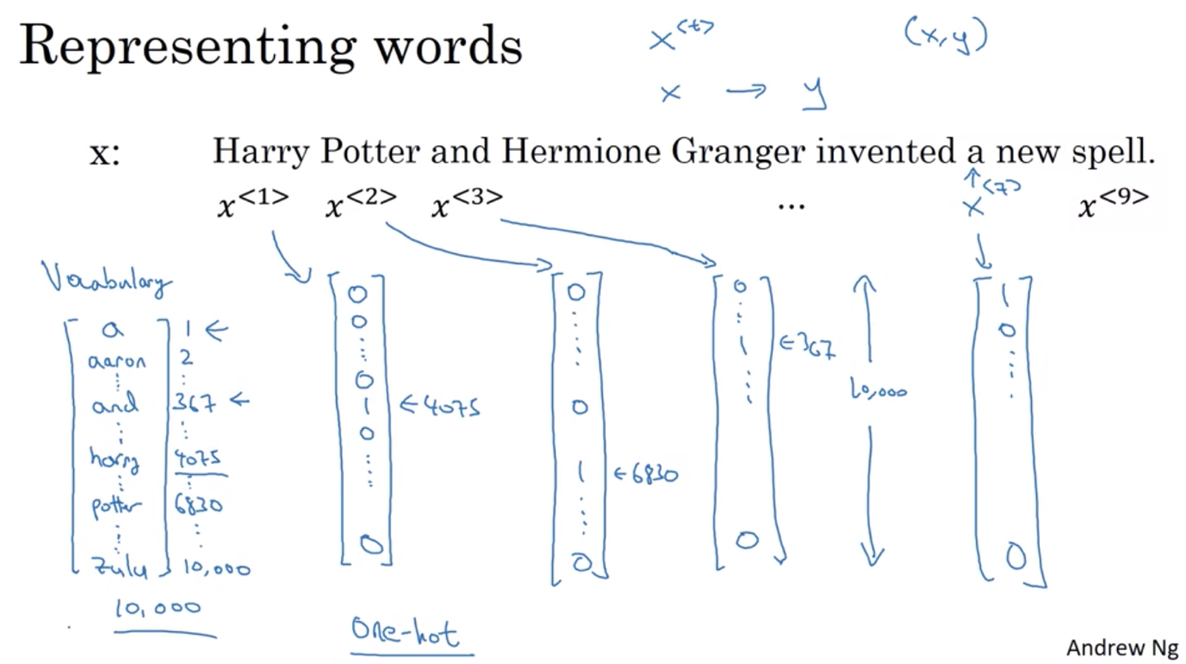

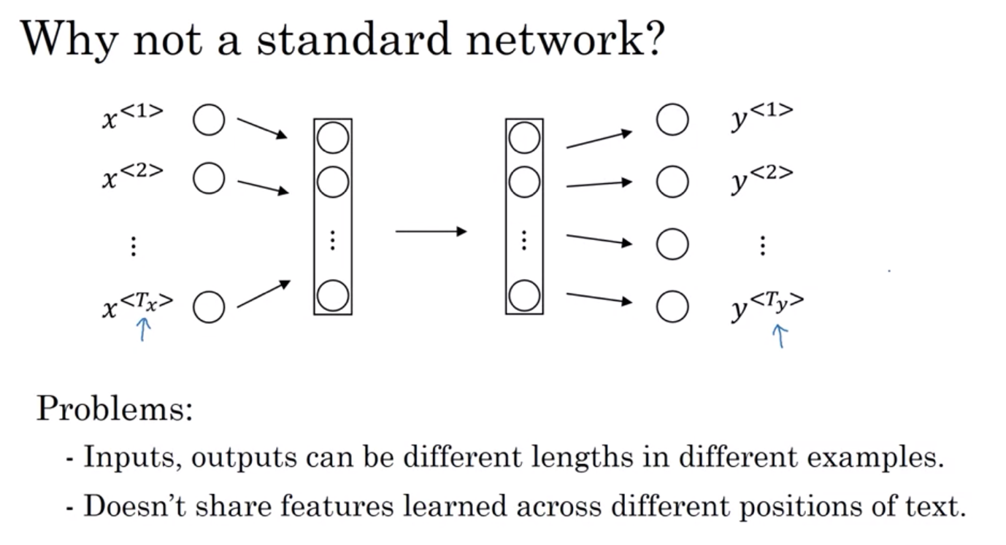

Recurrent neural network:

* Each time step, the neural network pass on its activation to the next layer
* Scans through the data from left to right. The time steps used in each parameters are shared
* So when making prediction for yhat3, it takes info from x3 but also from x2, x1
* Weakness: only use info from previous sequence (ex: like Teddy => if doesn’t have the info of the sequence after -> would be hard to decide if it’s a name or a word) => use Bidirectional RNN

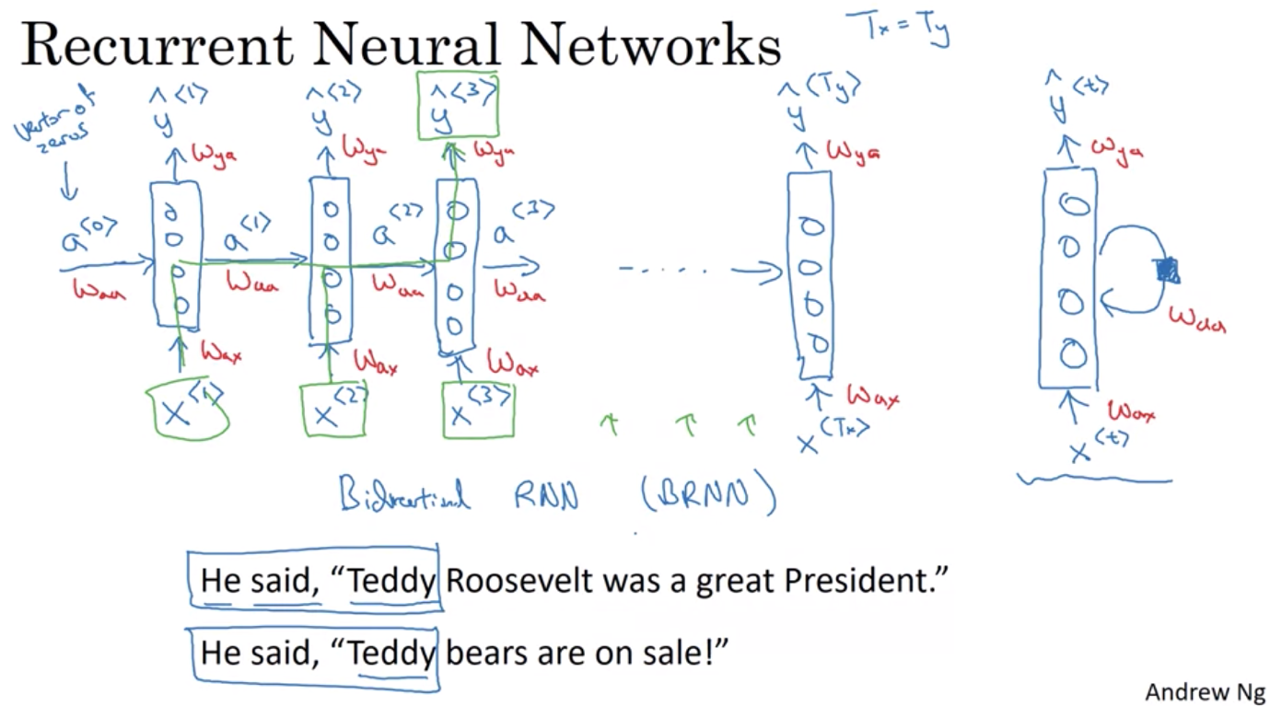

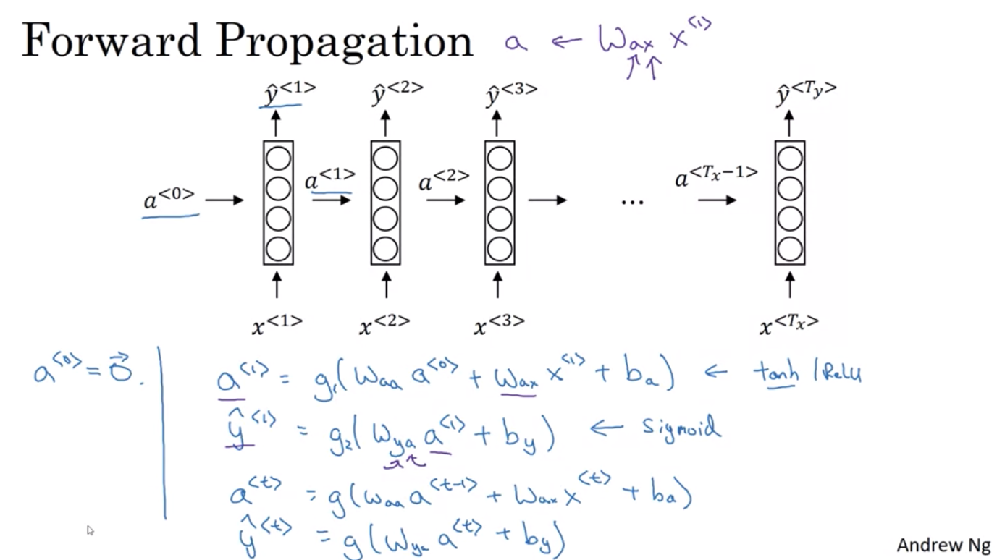

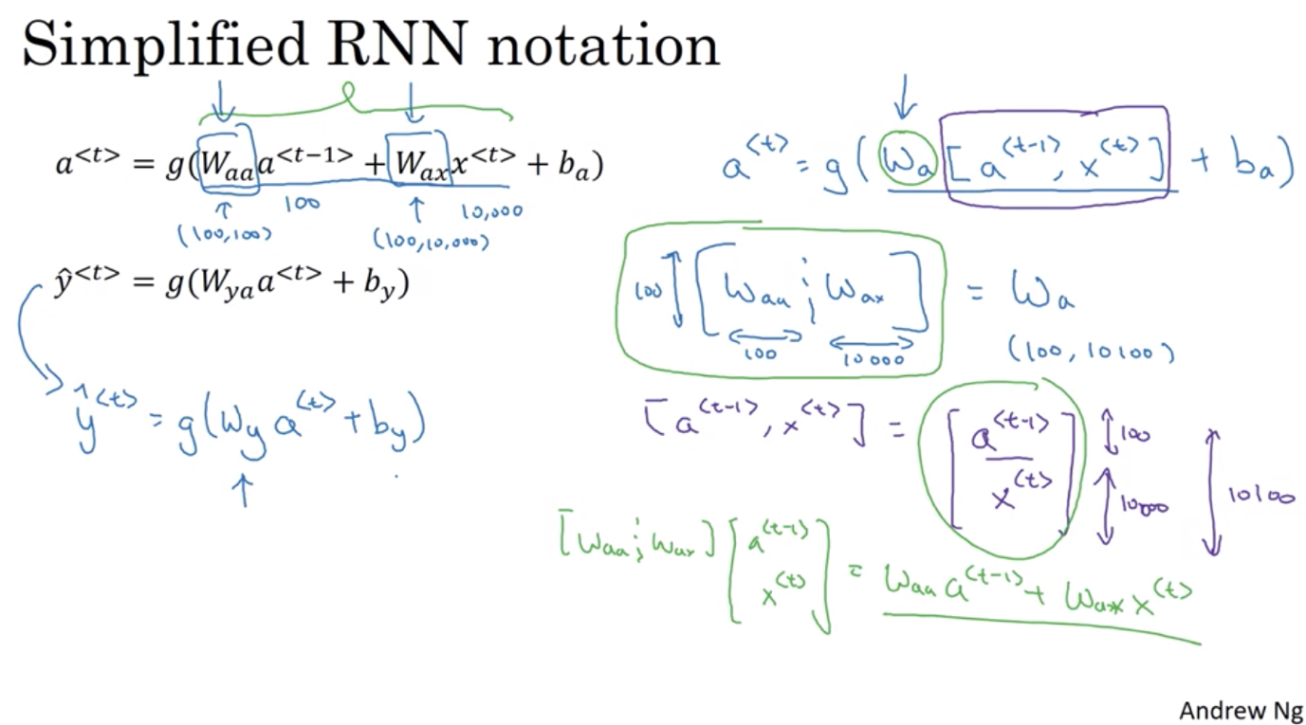

Backward propagation and how you learn with RNN

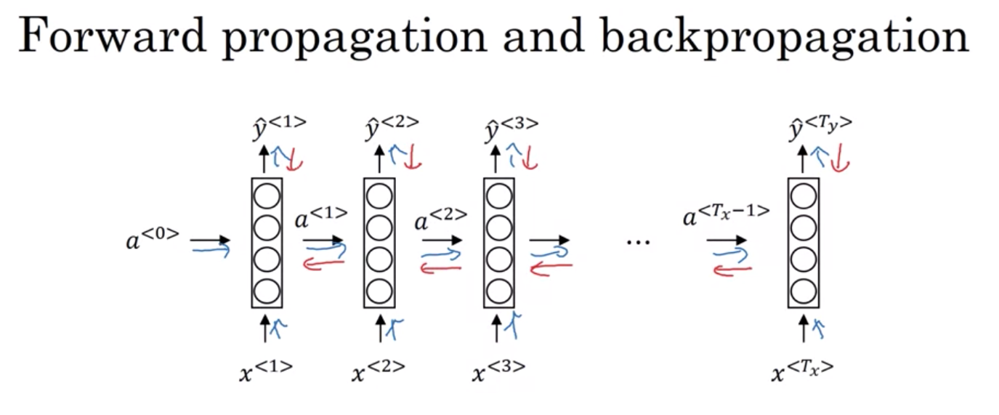

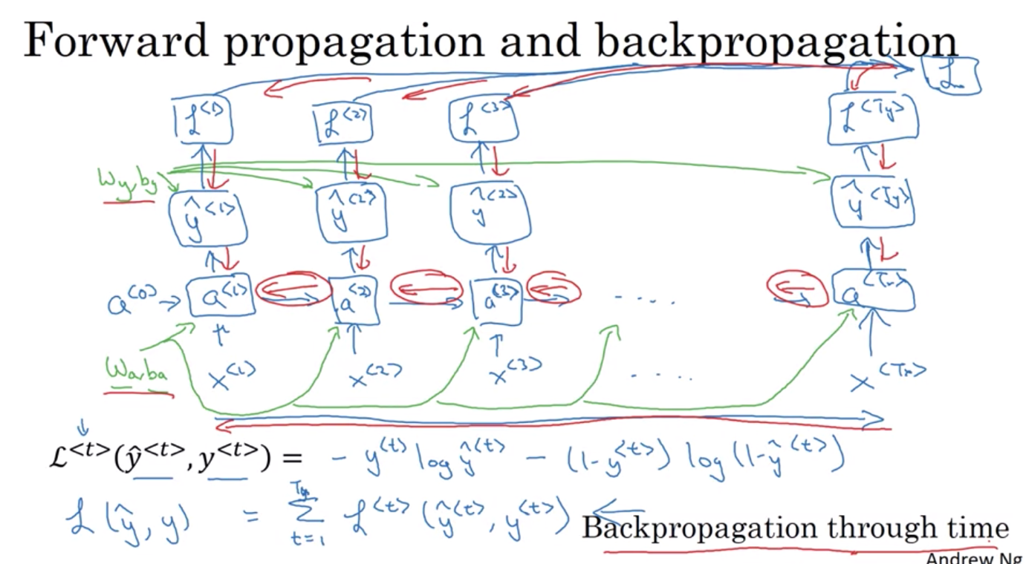

Different types of RNN

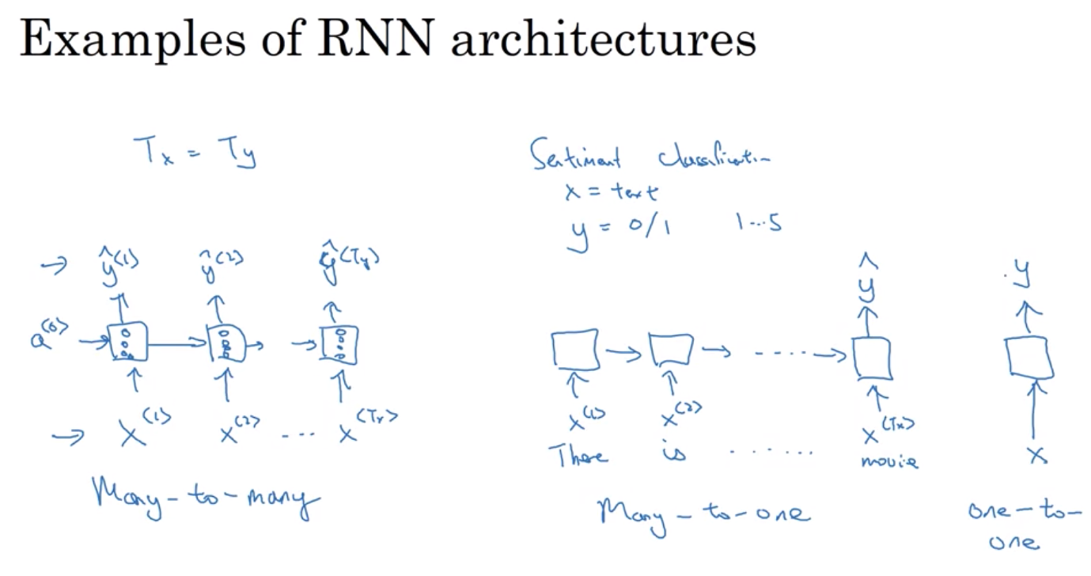

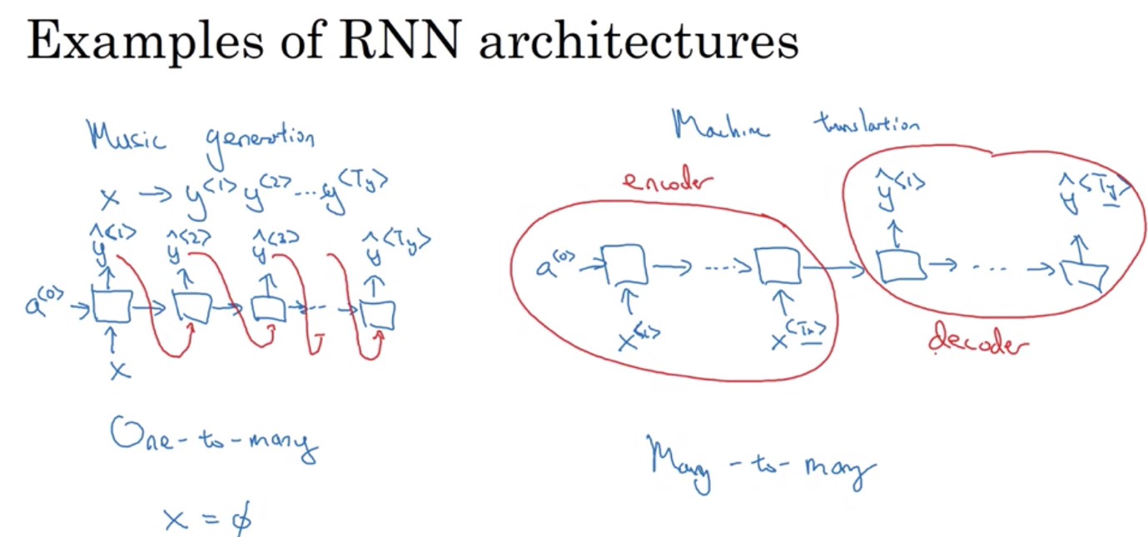

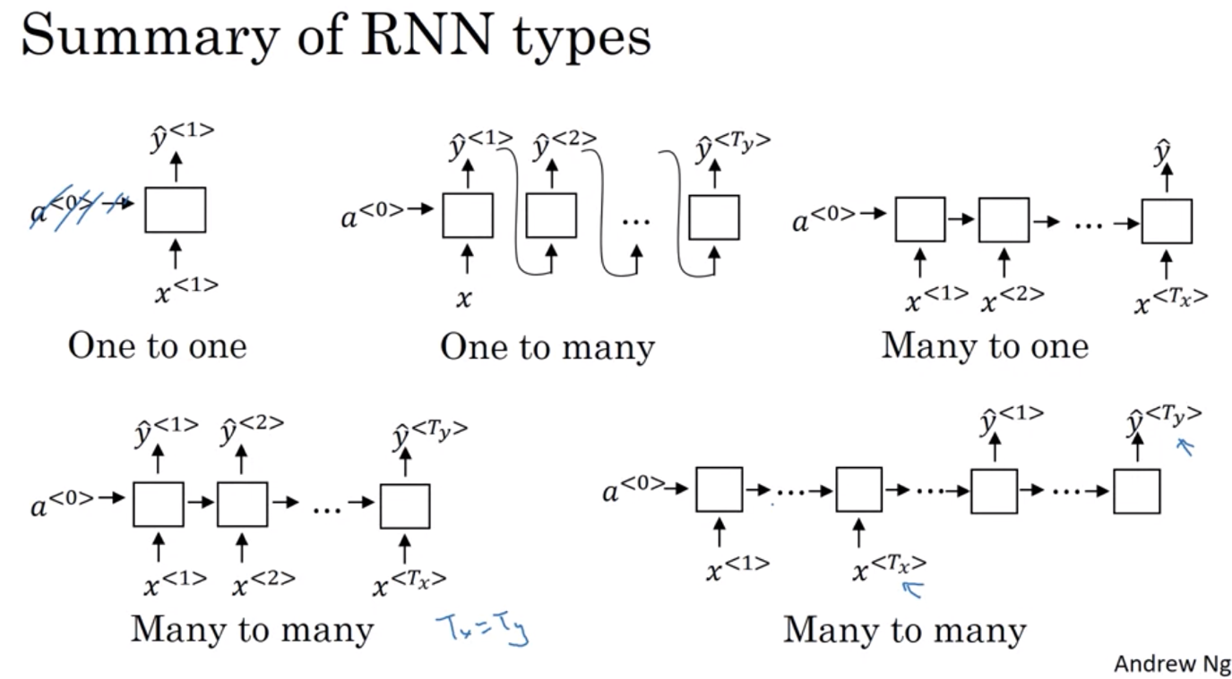

Language model and Sequence Generation

Basic job of a language model: output a sentence that is more likely, estimate the probability of a sequence of words

* Corpus: a large body of text
* Tokenize: form a vocabulary, and then map each of the words into one-hot vectors/individual tokens in your vocabulary
* EOS: end of sentence: extra token which lets you know where the sentence ends.

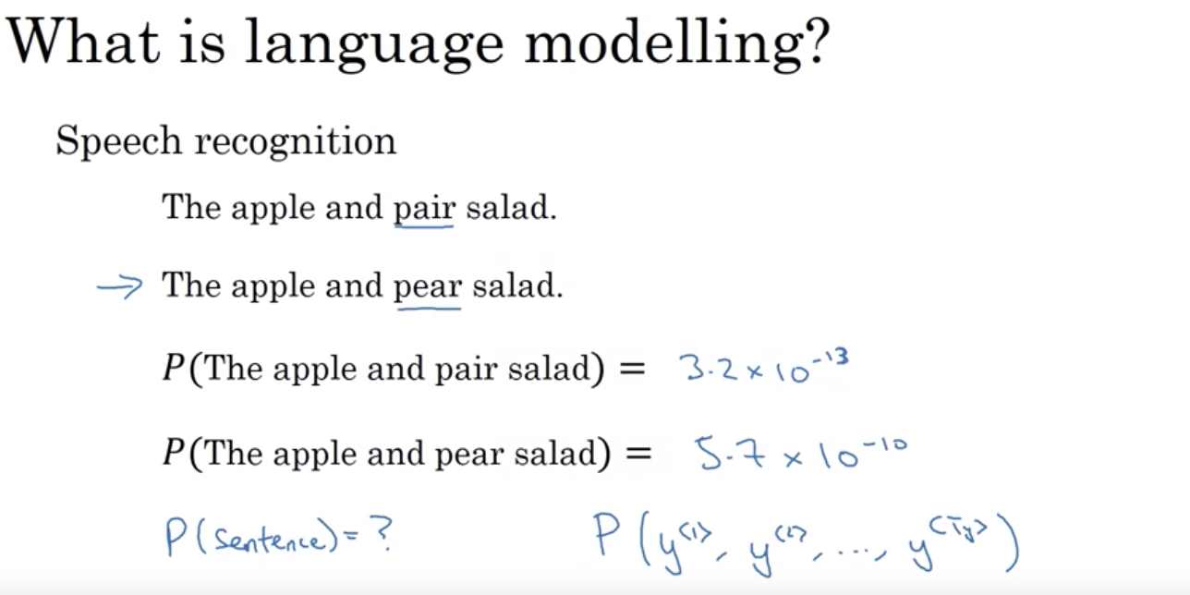

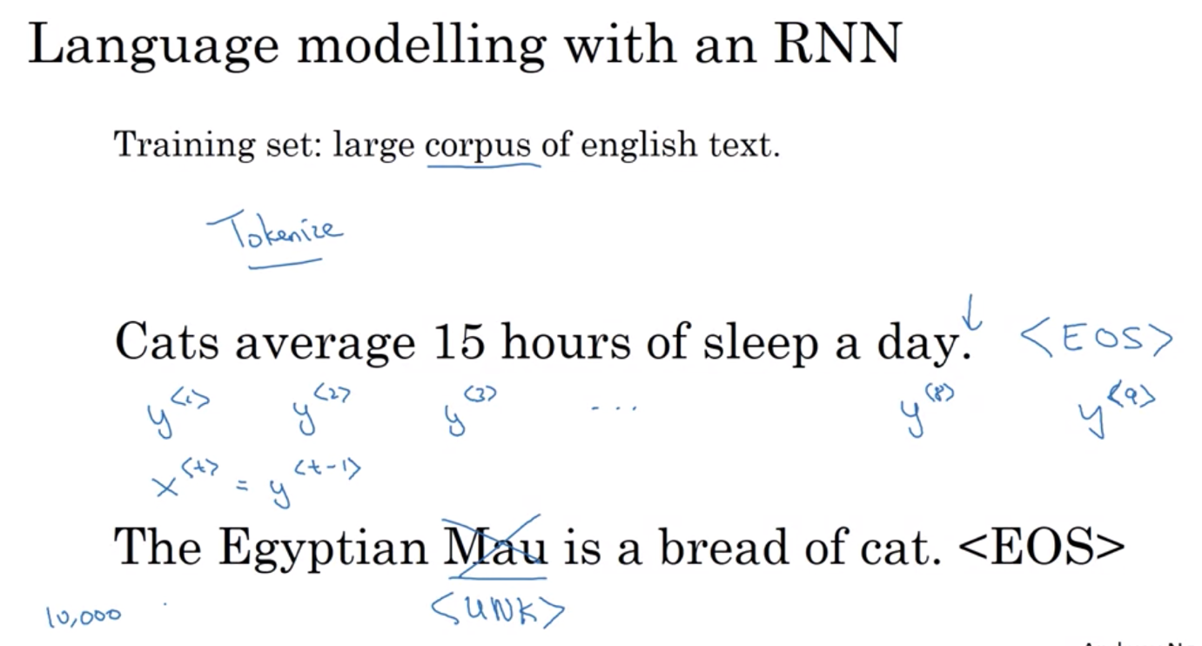

RNN Architecture:

* 1st word: softmax to find the probability of each individual words in the corpus
* 2nd word: softmax to predict what’s next given what’s come before (add in the info on the 1st word)
* 3rd word: give info on the first 2 words
* Each step of RNN will look at the preceeding words => RNN learns to predict one word at a time going from left to right

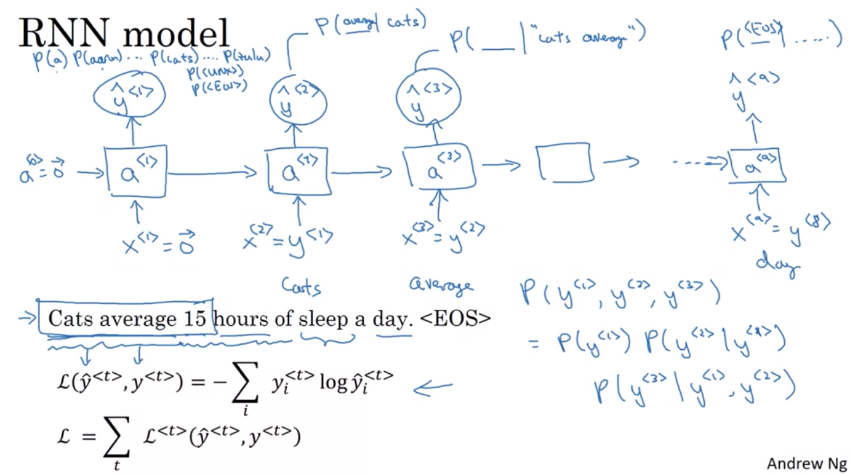

Sampling novel sequences

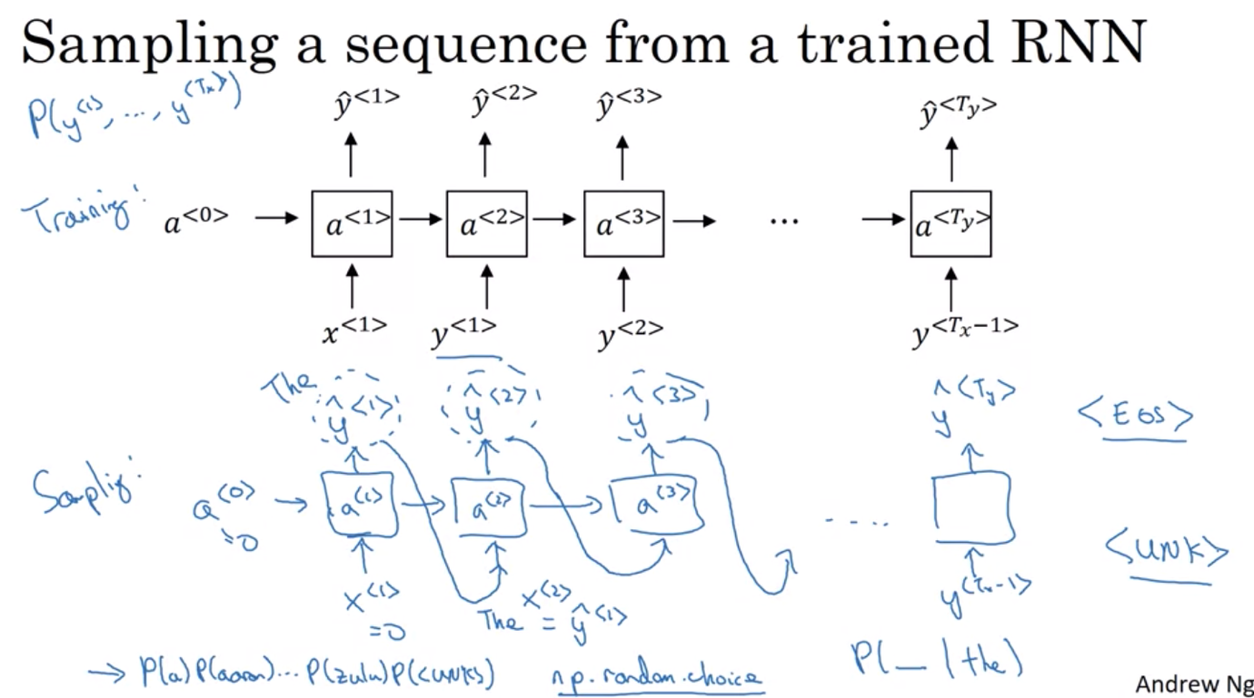

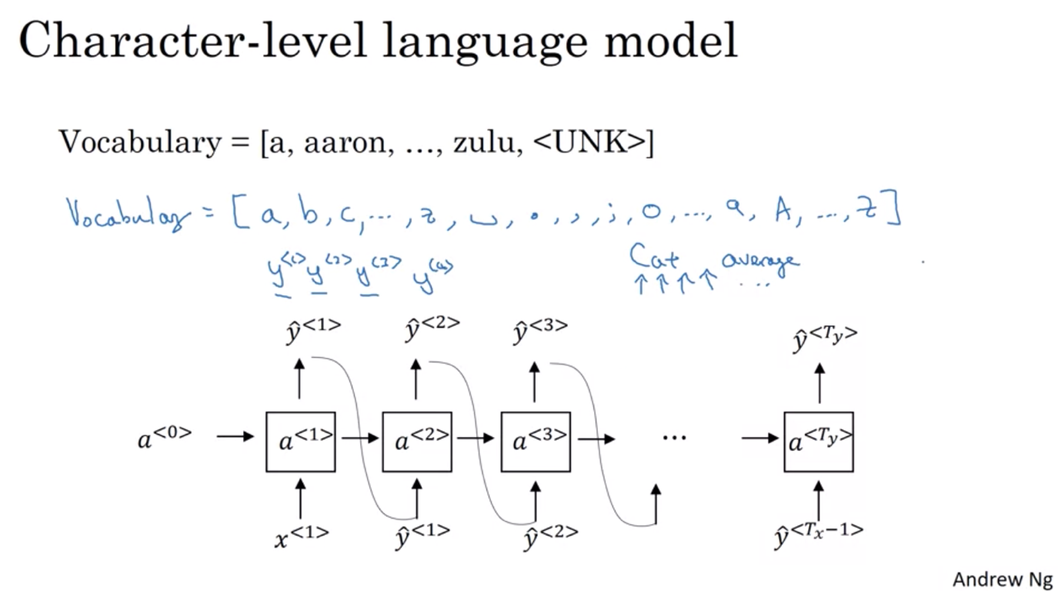

Character-level language model:

* Don’t have to worry about unknown
* But have long sentences + more computationally expensive
* Not good at long term dependencies (word/characters that appear before have consequences long after: ex: The cats……have/The cat……….has)



Vanishing gradient problems in RNN

* It takes a long time for the gradient from y to be backpropagated through the network and modify/influence how the network is trained and computed in the earlier steps of the sequence
* Have many local influencers: y hat is mainly influenced by values close to y hat
* Weakness of the current RNN architecture to capture long-range dependencies
* If we encounter exploding gradients: use gradient clipping

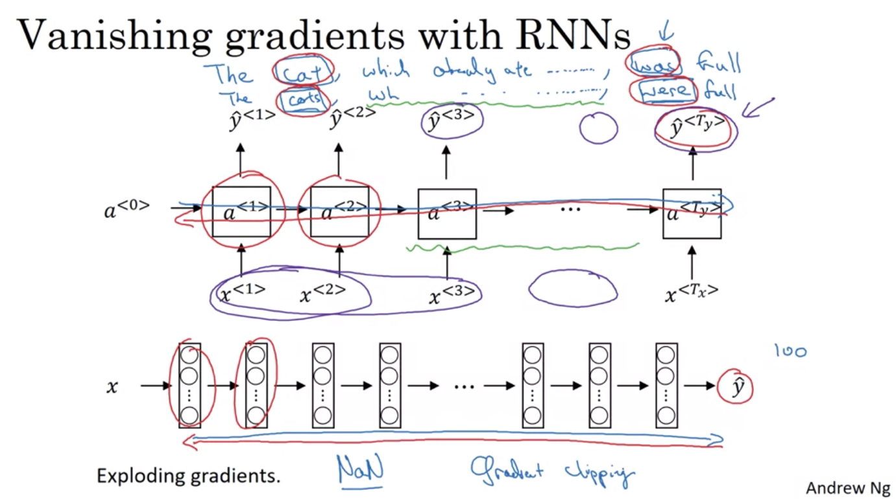

GATED RECURRENT UNITS (GRU)

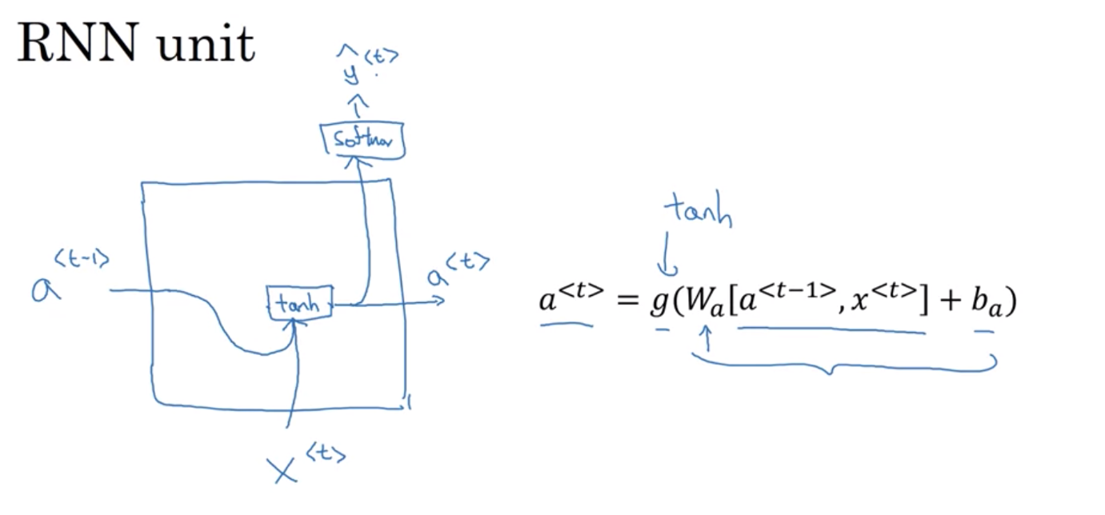

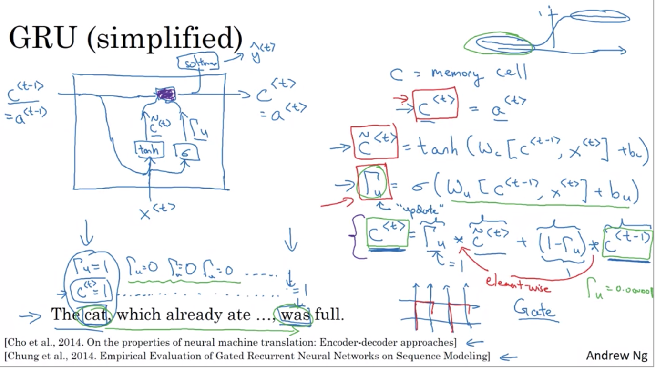

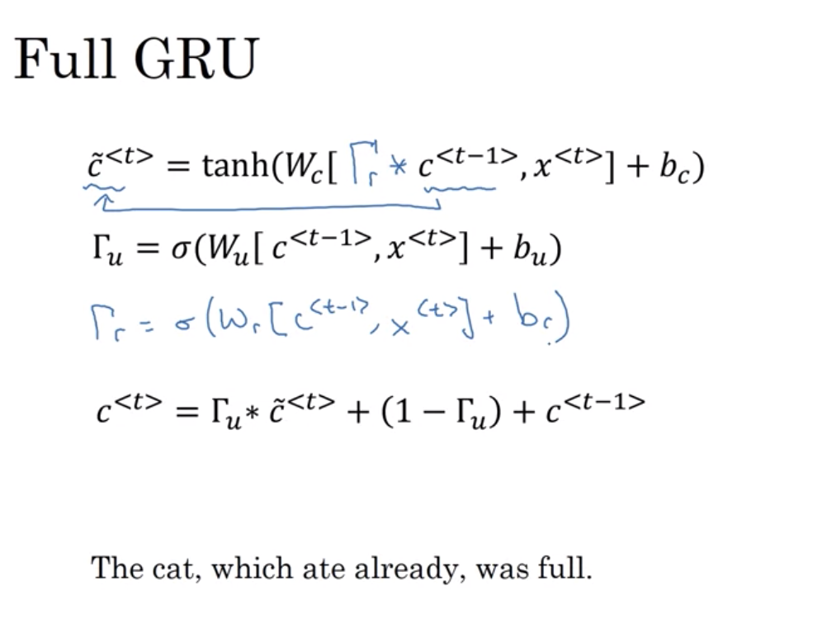

Gamma r: how relevant the memory cell is

LONG SHORT TERM MEMORY (LSTM)

2 separate update gates (1 update, 1 forget) + output gate

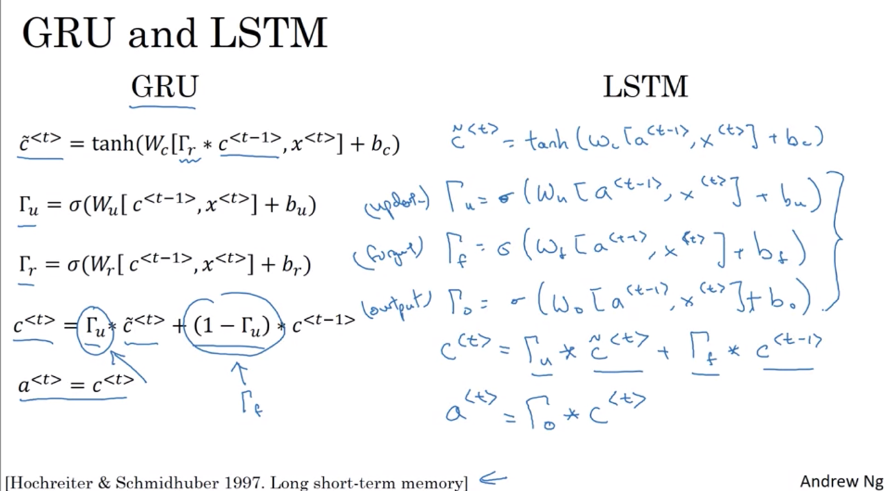

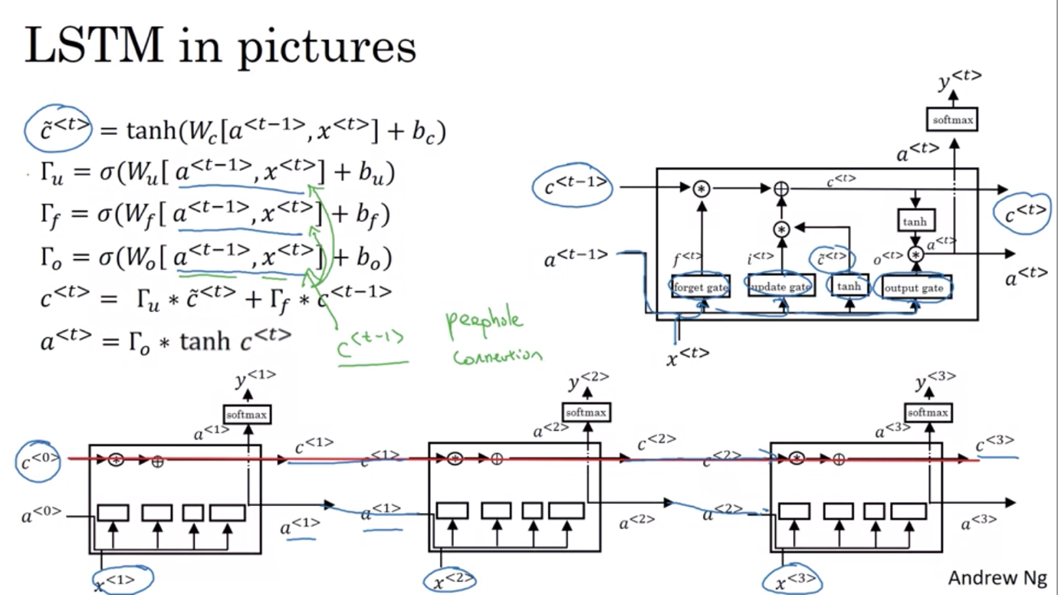

Bidirectional RNN

* Allows you to take info from both earlier and later in the sequence

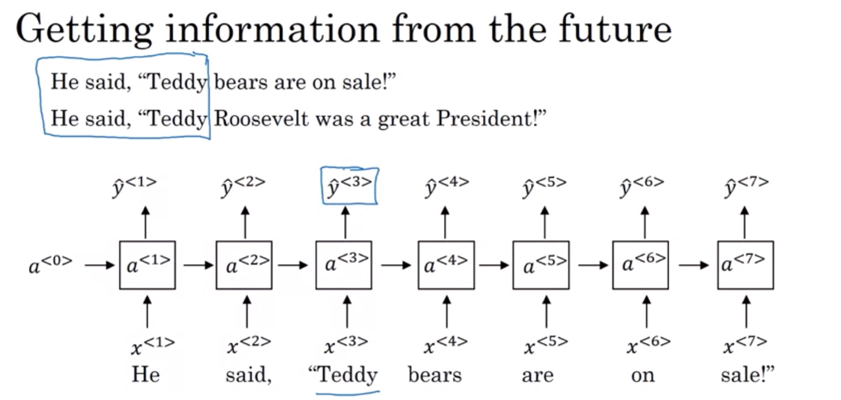

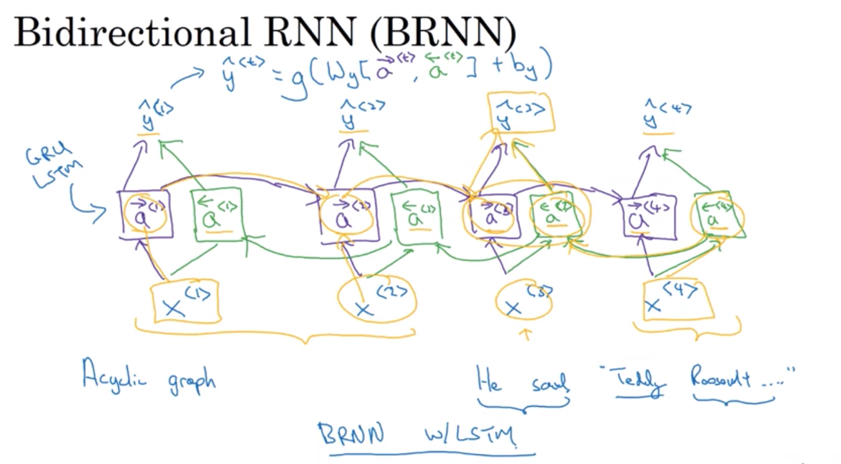

Deep RNN

